TUẦN 1 TỪ NGÀY 6/9-11/9/2021
UNIT 1: HOME
Lesson 1: Vocabulary & Listen ( page 6 – Student’s book)
1.VOCABULARY (TỪ VỰNG)
No | Words |  | Transcription | Meaning
1 | apartment | (n) | /əˈpɑːrt mənt/ | Chung cư
2 | balcony | (n) | /ˈbælkəni/ | Ban công
3 | basement | (n) | /ˈbeɪsmənt/ | Tầng hầm
4 | garage | (n) | /ɡəˈrɑːʒ/ | Nhà để xe, ga-ra
5 | gym | (n) | /dʒɪm/ | Phòng tập thể dục
6 | yard | (n) | /jɑːrd/ | Cái sân
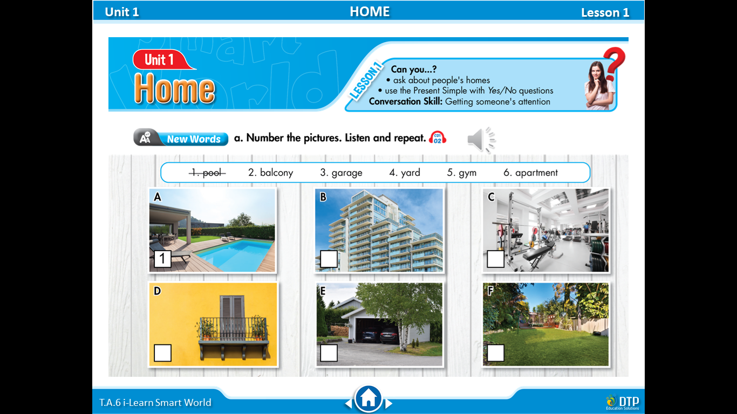

❷ Practice:

- (an) a²partment /ə’pa:tmənt/: căn hộ chung cư
………………………………………………………………………………….………………………………………………………………………………….………………………………………………………………………………………………….
- (a) ¹balcony /’bælkəni/: ban công
………………………………………………………………………………….………………………………………………………………………………….………………………………………………………………………………………………….
- (a) ¹garage /’gæra:_{Ʒ}/, /’gærid_{Ʒ}/, ga²rage /gə’ra_{Ʒ}/: nhà để xe
………………………………………………………………………………….………………………………………………………………………………….………………………………………………………………………………………………….
- (a) gym /d_{Ʒ}im/: phòng tập thể dục
………………………………………………………………………………….………………………………………………………………………………….………………………………………………………………………………………………….
- (a) pool /pu:l/: hồ bơi
………………………………………………………………………………….………………………………………………………………………………….………………………………………………………………………………………………….
- (a) yard /ja:d/: cái sân
………………………………………………………………………………….………………………………………………………………………………….…………………………………………………………………………………………………
- Further practice:
Write the suitable word for each picture.
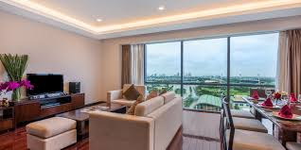 | 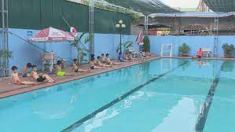 | 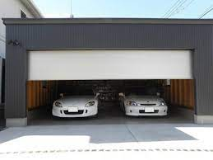
1. | 2. | 3.
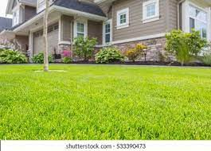 | 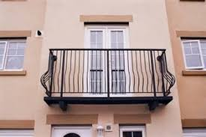 | 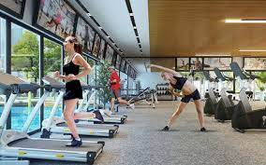
4. | 5. | 6.

II. Fill in the blanks with words from the unit. The first letter is already there.
(Student’s book, Review 1. Page 87)
1. I like sitting outside on my _balcony_ when it's hot.
2. North, East, South, and _W_________ are the four cardinal points of the compass.
3. After eating dinner, I do the _d_________.
4. I live in the countryside. My _v_________ is very small. It only has a few houses and one store.
5. My house has a very big _y_________. I like playing soccer there with my friends.
6. Does your uncle live in a villa in Ha Noi? - No, he doesn’t. He lives in an _a__________.

III. Fill in the blanks using the words in the box. (Workbook, Unit 1. Page 2)
balcony | village | yard | garage | city | pool | flowers | gym | apartment
1. My mother goes to the__________ twice a week.
2. A__________ is in the countryside and usually has a few houses.
3. Does your apartment have a__________?
4. Did you park the car in the__________?
5. A: Does your house have a big__________?
6. B: Yes, it does. We plant trees and__________ there.
7. We asked for a hotel room with a__________.
8. Our__________ is small and has two bedrooms.
9. A__________ has many big buildings, schools, parks and hospitals.

---The end ---

